|  |
| --- |
|  |
|  |
|  |

**House Address:**

1080 Coronado, CA

**Project Description:**

1. Design of a two story house.
2. Three Bedroom, 6 bathrooms.
3. Hacienda style.

**Team Members:**

-Project Manager:

Karlianna Salas

-Drafter:

Maritza Rico

-Cost Estimator:

Victor Lira

1

|  |
| --- |
| **Dream Design**  **Address: 1080 Coronado CA**  **Drafter: Maritza Rico.**  **Project Manager: Karlianna Salas.**  **Cost Estimater: Victor Lira.** |

**Index:**

1. House Description

2. Site Plan and vicinity map

3. First floor plan

4. Second floor plan

5. Front and rear elevations

6. Left and right side elevations

7. Proposed Cost spreadsheet

**Zoning Laws:**

-Front Setback line: 25 ft.

-Back setback line: 15 ft.

-Left setback line: 4 ft.

-Right setback line: 12 ft.

**Total Living Area:**

5,185.27 sq. ft.  
First Floor: 2,656.27 sq. ft.

Second Floor: 2,529 sq. ft

Vicinity Map. Site Plan



2

First Floor Plan

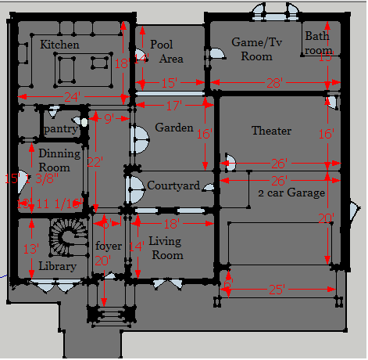

3

Second Floor Plan

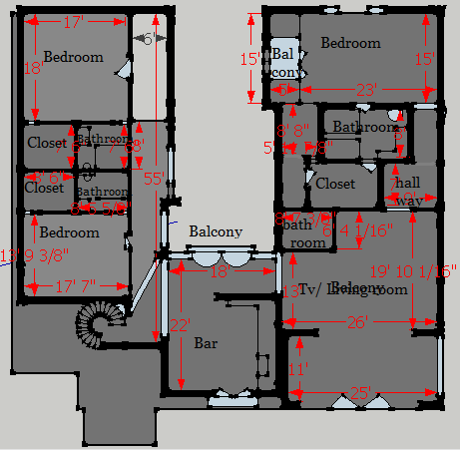

4

Front Elevation Rear Elevation

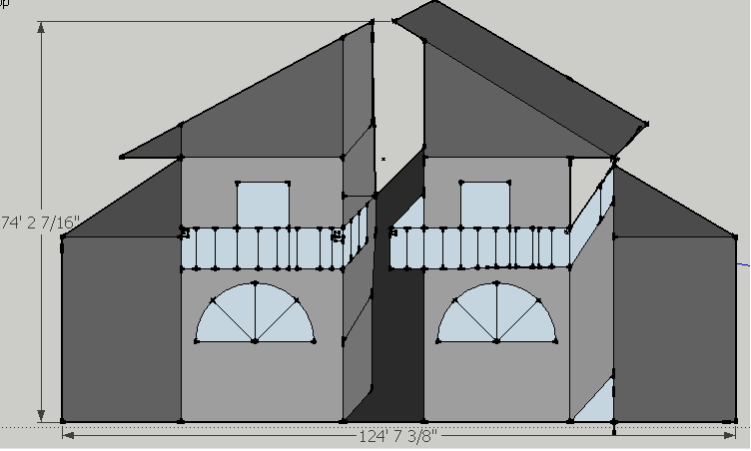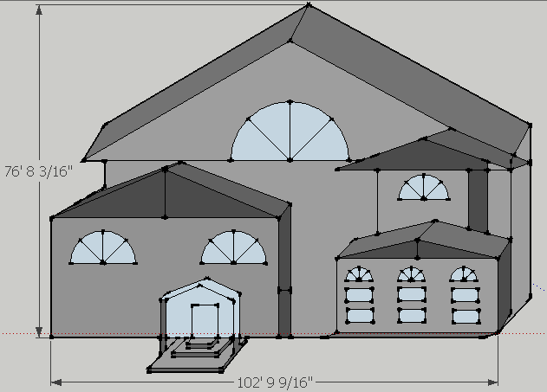

5

Side Elevations

Left Elevation Right Elevation

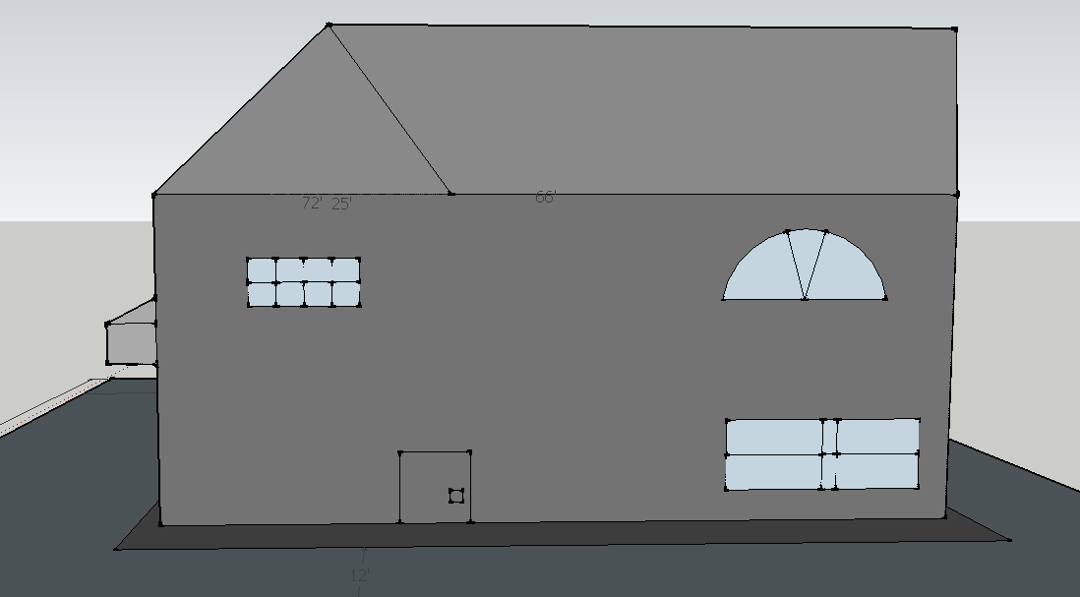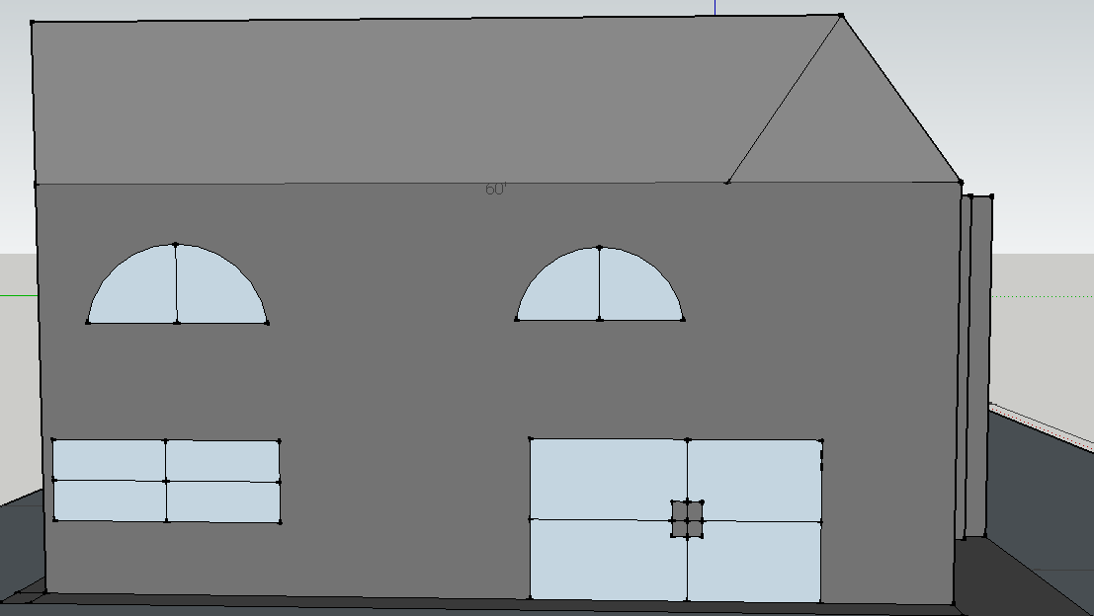

6