Adventures in the Unknown
The little moth flew with his little wings around the backyard of the house he used to see every day in his normal routine. He had never gone in it though; the windows were locked and were sprayed with insecticide venom. He knew it because some of his friends had tried to go in and never made it. But as he flew around the house he saw the front door open. As quickly as he could, he flew in. The atmosphere was different there, the smell was artificial and it was warmer than his natural surroundings.
He looked around and could see various different objects, one of them being a flat black rectangular object that displayed different colors, lights and sounds. He stopped on a soft surface it was cushiony and bouncy. Next he flew into what seemed like an enormous sphere of light, as he tried to touch it he hurriedly stepped off as it was burning his tiny legs. He didn’t like this place, it was getting suffocating. The room, although it was millions times his size, still was contained, unlike anything he was used to; it felt trapping and limiting compared to the free endless skies he knew. He wanted to find a way out, but first something to eat. His corporal hairs didn’t smell any food nearby so he kept looking.
Next he flew into another room. He could see and hear stomping and human figures. He knew this was danger. Humans didn’t like the moths; they killed, slapped and even poisoned them for even coming close to their belongings. The moth tried to fly away but another door was opened so he went inside as he thought the light would guide him somewhere out. The room was white and bright and really cold.
He smelled food, so he kept looking. He sucked a fruit that he found, finally something good! The door was opened again and the human saw him. The fruit was picked up by an enormous hand that moved in up and down as if trying to smack the moth away. The moth flew away at fast as it could, to find another door opening and went after it.
He could see the human figurine moving towards a huge box like object, with a light inside. Light! Light meant a way out. He flapped his wings up and down and flew into it. He could hear wave-like sounds when all of a sudden the room became dark. Smell, he smelled meat, food. The atmosphere started getting really heated. His hairy body helped him retain his internal body temperature. He searched for a way out of that oven. It was too hot, 5 more seconds and he’d have all he could take. Beep. A loud sound emerged through the hairs on his body. A light again, that human again, he flew out flapping his wings as fast as he could returning to its normal temperature. That was close, he thought to himself. Find a way out, was all he had to do.
Light, he saw light again. Flapping himself he increased his momentum. Trees, he recognized, plants, flowers, nature, all of those familiar. He flew even faster. To find himself slamming against a flat surface, the little body fell flat on a different surface. Still alive, he got up on his weak limbs, walking on his legs now to explore his new surroundings.
He found himself on a new surface, cold and smooth. Giant blobs of water surrounded him; he had to walk around them to keep from getting wet. It was like a labyrinth. He was getting good at this, dodging and avoiding the huge plumps of liquid. Until something even more unexpected came about, a giant waterfall emerged from the sky and filled his surroundings with water, thankfully, his wings had recovered and he was able to fly away as fast as he could, he needed to find another place to hide or escape to.
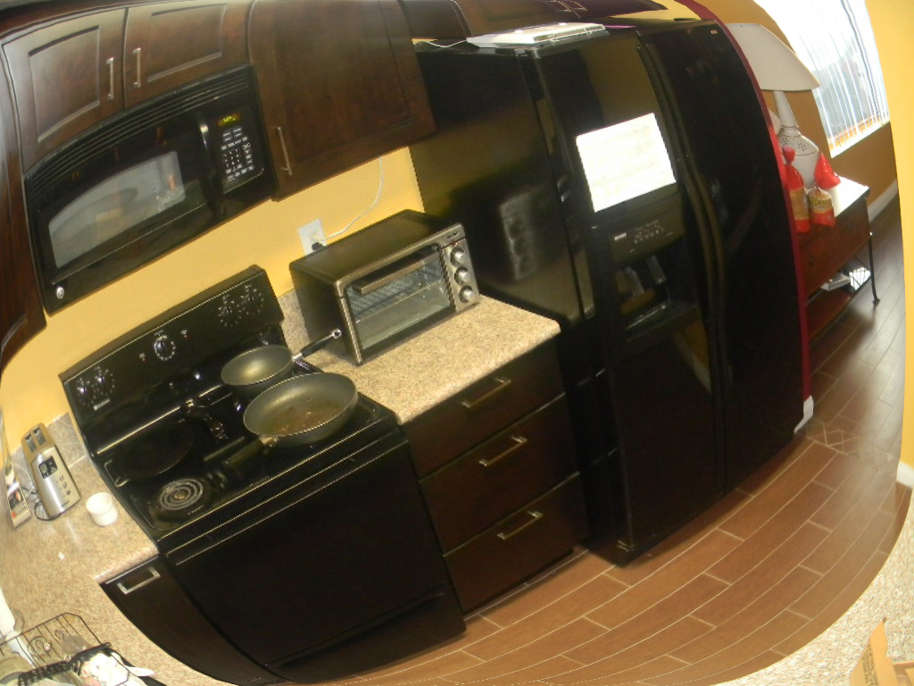
When finally a ray of light hit his fibers, he knew this was his time to get out. Flapping his wings he flew out straight from where he came from. To find himself back surrounded by the lovely smell of trees, grass and nature, that he was so familiar with.

