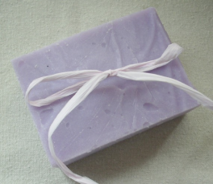

Soap Chemistry 101:

All soap, including all Girl In Motion soap, is made using a combination of lye, a basic substance, and fats or oils, an acidic substance. The two balance each other for the most part, creating a slightly basic solid substance.

Soap itself works to remove dirt and other oily substances from your skin by being an emulsifier, a substance that’s molecules have a polar, or charged, end and a non-polar, or uncharged end. Water is polar and oils are nor-polar, and in the world of chemistry, the two do not mix. The non-polar end of a soap molecule or a triglyceride is the long carbon chain. This non-polar carbon chain bonds with non-polar oils on the skin, while the polar end of the molecule bonds with the washing water. Soap acts as a bridge between the oils and the water, and thus is able to wash away oily dirt and grime.

Ingredients: Sodium oleate, sodium palmitate, sodium laurate, sodium ricinoleate, sodium linoleate, sodium caprate, sodium alpha linoleate,

sodium stearate, sodium dihydroxy-sterate, glycerine, water, peach blossom

fragrance.

Girls, we know what you want from your soap. You like to play hard and get things done, and you expect your cosmetic products to be able to do the same. We understand, which is why we at Girl in Motion have come up with the Peach, designed to make you look and feel your best wherever you go, and whatever you dare to do. The Peach is made from natural soothing oils, such as coconut, palm, and olive. Nonetheless, it still has what it takes to keep you clean and on your game. Our soap is fierce, focused and feminine, just like you.

Peach Blossom Soap

GIRL IN MOTION

Fierce, Focused, Feminine