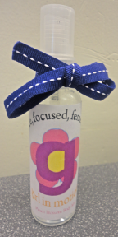

Deodorants’ unique anti-odor capabilities lie in their ability to block sweat and their added essential oils. A thin layer of aluminum compounds coat sweat glands under your arms, while the perfume smothers offensive odors before they start.

Ingredients: Coconut oil, arrowroot powder, baking soda, beeswax, lavender fragrance, castor oil.

Girl In Motion’s latest product is Lavender Glide Deodorant, a smooth addition to our other peach-scented counterparts. It may be small, but it

will keep you smelling fresh all day, no matter what active endeavourers you pursue.

The essential oil of peach blossoms are what makes this product possible! The oils slowly evaporate off of your skin and into the scent glands of the people around you. Essential oils have been used in a variety of cosmetic products for thousands of years. Here at Girl In Motion, we have used two different scents in our products: peach blossom in our soaps and perfumes, and lavender in our deodorant.

Our second peach-scented item available is the Blossom Body Mist, a sweet, enticing perfume suitable for any occasion. Scented with peach blossom essential oils, the Blossom Body Mist is a carefully created substance that we at Girl In Motion are sure you will enjoy.

Ingredients: Water, ethanol, peach blossom fragrance.

Lavender Glide Deodorant

Blossom Body Mist

GIRL IN MOTION

Fierce, Focused, Feminine